Lesson 06 Demo 4
Ansible Modules
Objective: To implement Ansible Module through command line.

Pre-requisites: You need to have Ansible installed in order to proceed with this demo. If you don’t have it installed, refer to demo 1 of lesson 7.

Tools required: Ansible.

Steps to be performed:
1. Execute Ansible modules on a local server.

Step 1: Executing Ansible modules with local server

1.1 Run the below commands in the given sequence to execute different Ansible
modules.
ansible -m setup webservers


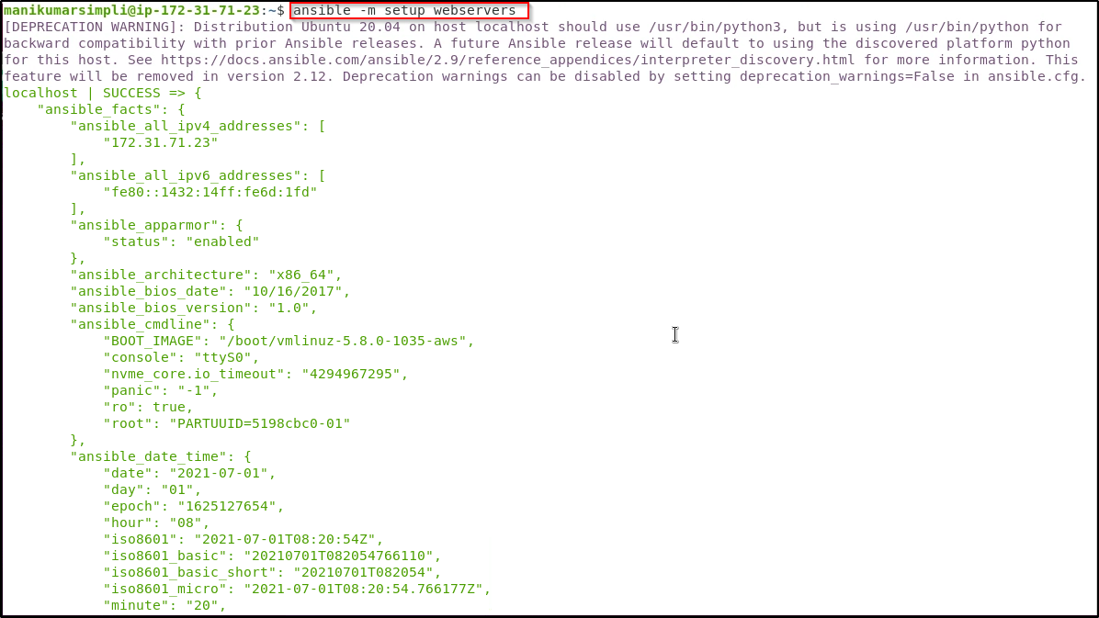

ansible webservers -m shell -a 'hostname'
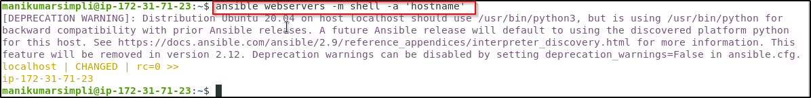

ansible webservers -m apt -a 'name=git state=present' --become
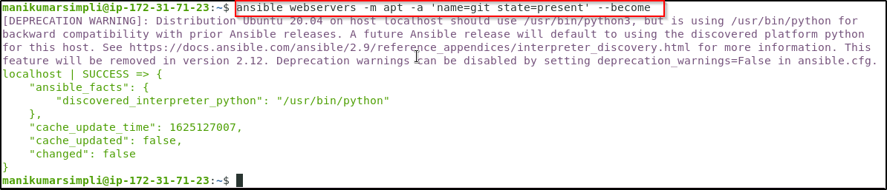

ansible webservers -m file -a 'dest=/root/sample.txt state=touch mode=600 owner=root group=root' --become



